Aircraft
The aircraft desk had a very busy season supporting local and extended attack fires in the SCOFMP area as well as out of area incidents. The Klamath Falls Tanker Base hosted two heavy airtankers for the second half of fire season. Two CL-415 were stationed at Klamath Falls Tanker Base supporting Two Four Two, Brattain, and Thielsen Incident on the Umpqua. Per the region an additional Surge Helicopter was hosted and staffed by the Lakeview Helitack crew. Prescott Helitack, Superior Helitack and ODF John Day Helitack also completed details on SCOFMP increasing capacity during the busy season.

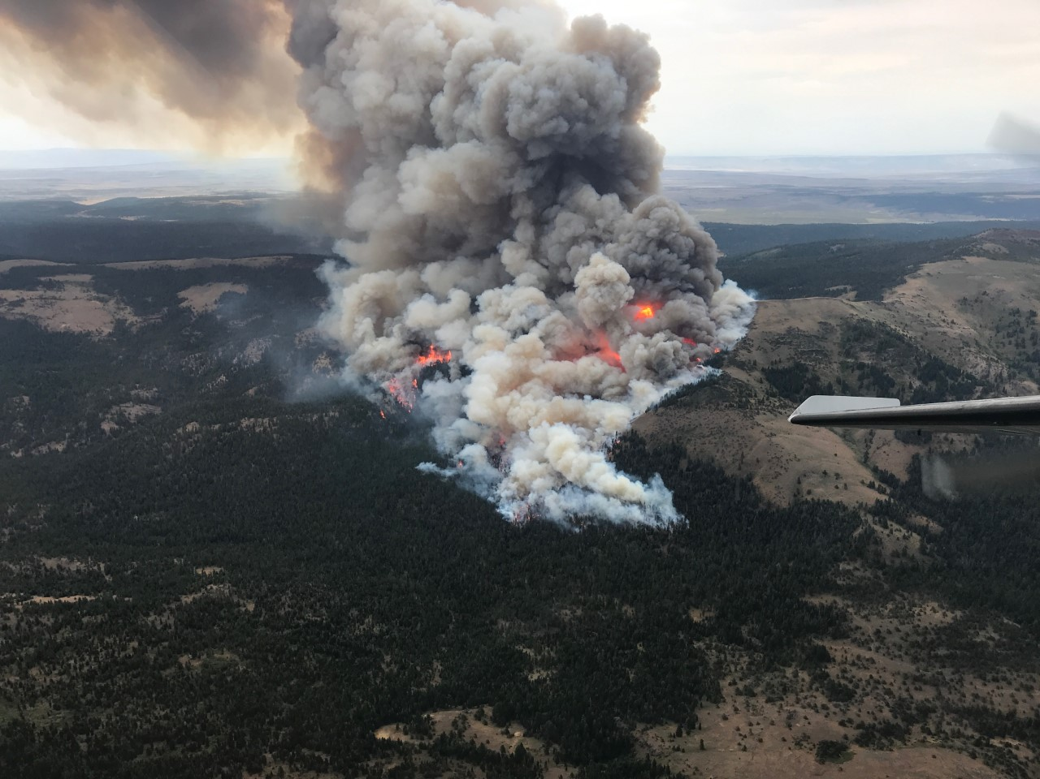

Crane Fire

T-810 Western Pilot based at Lakeview Seatbase. On contract for 71 days with a contract extension of 10 days. Flew 26 Initial Attack Fires, and 4 Extended Attack Fires.
Delivered a total of 64,433 Gallons of Retardant
Total Flight Hours = 47.11

T-896 Western Pilot based at Lakeview Seatbase. On contract for 104 days with a contract extension of 14 days. Flew 34 Initial Attack Fires and 3 Extended Attack Fires.
Delivered a total of 73,138 Gallons of Retardant
Total Flight Hours = 58.45

T-846 Aerial Timber was an additional On Call seat based at Lakeview Seatbase for the GACC. Was on call contract for 36 days. Flew 5 Initial Attack Fires and 2 Extended Attack Fires.
Delivered a total of 24,599 Gallons of Retardant
Total Flight Hours = 27.16
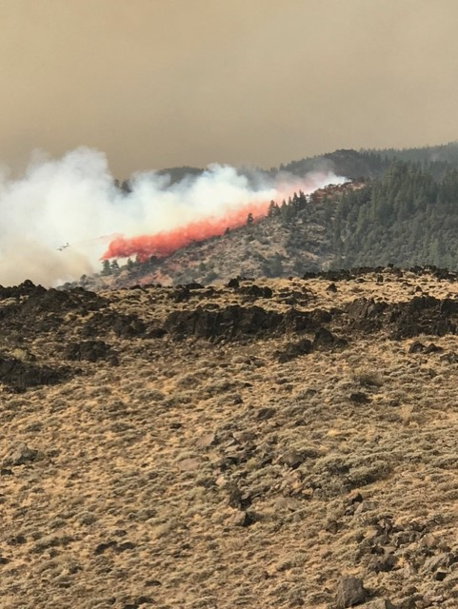

Klamath Falls tanker base
In 2020 the Klamath Falls Airtanker Base delivered 177 loads of LC95-A-R retardant.

Retardant Gallons Delivered by Agency
USFS Region 6 | 120,014
USFS Other | 121,123
BLM | 40,259
ODF | 66,211
NPS/BIA/CA | 22,885
Total | 370,492

For 2020 The Klamath Falls Airtanker base provided retardant for 6 different agencies, while supporting 14 different fires.

T-02 and T-16 used Klamath Falls as their home base during the second half of the season. Their stays were the longest continuous RONs that the Klamath Falls ATB has had in close to a decade.

Fast Facts for 2020
Base Opening Date: | 06/01/2020
First Load of Season | 07/20 “Gold”
Last Load of Season | 09/15 “Brattain”
Base Closing Date: | 10/17/2020

Fast Facts for 2020
Airtankers in One Day: | 11 Sept 8th “Two Four Two”
Incidents in One Day: | 4 July 22nd and July 23rd
Loads in One Day: | 39 Sept 8th “Two Four Two”
Gallons in One Day: | 60,927 Sept 9th “Two Four Two”

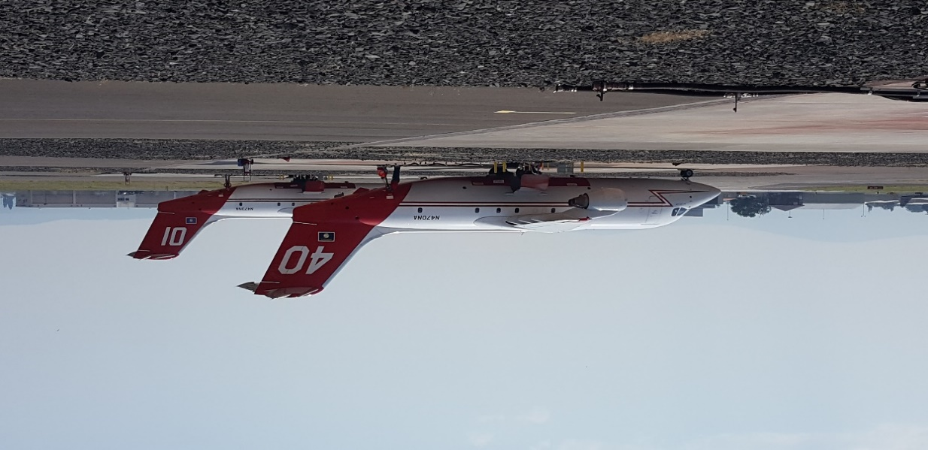

Air attack
Air Attack 3ME was contracted through Ponderosa Aviation with an Aero Commander-690B for 120 days June 1st through September 28th.
Highlights
Initial Attack Fires= 20
Extended Attack Fires= 32
Total Hours Flown= 154.33
Hours Flown On Zone= 104.04
Hours Flown Off Zone. 50.29
Trainee: 1 for 44 days

lakeview Helitack
H-7HX was contracted through Helicopter Express on year 2 of a 5 year contract. Contract started on May 31st and ended on September 17th with an extension until October 27th.
Highlights
Total Revenue Flight Hours= 175
Hours Flown On Zone= 75
Hours Flown Off Zone= 100
Initial Attack Fires= 18
Transported Passengers= 392
Gallons of Water Delivered= 146,828
Pounds of Internal Cargo Delivered= 33,600
Pounds of External Cargo Delivered= 5,549

